**ANNA UNIVERSITY REGIONAL CAMPUS CHENNAI**

 

**IBM PROJECT REPORT**

**PERSONAL ASSISTANCE FOR SENIORS**

**WHO ARE SELFRELIANT**

EXECUTED BY:



**Batch                :  B6-6M2E**

**Team id            :  PNT2022TMID26050**

**Team leader    :  POOJA D K S**

**Team members     :  APARNA D**  **, NARMADHA R, AKSHAYAA V**

**CONTENTS**

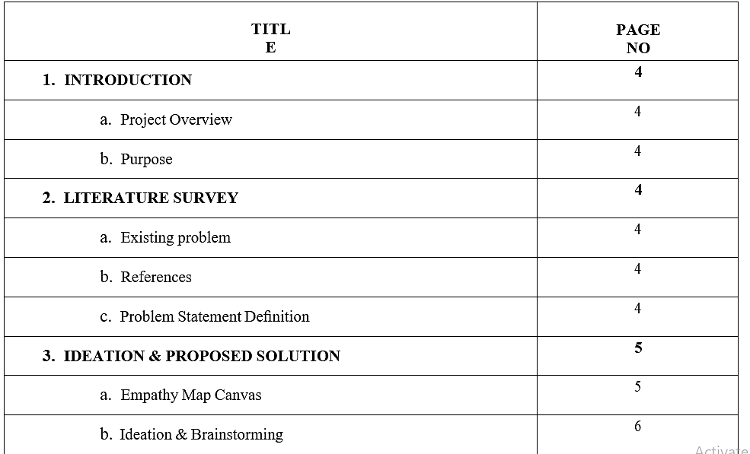  
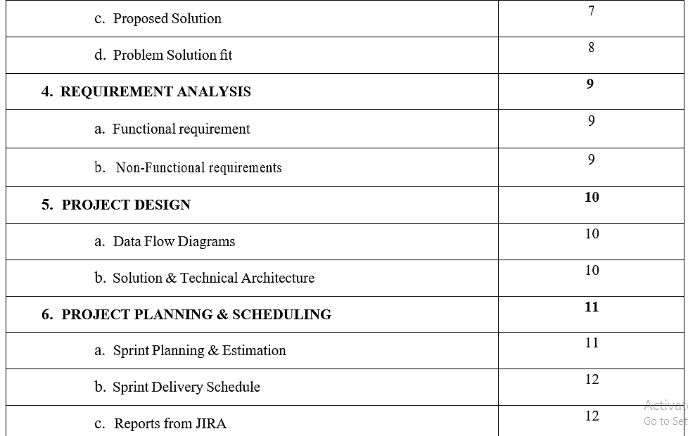

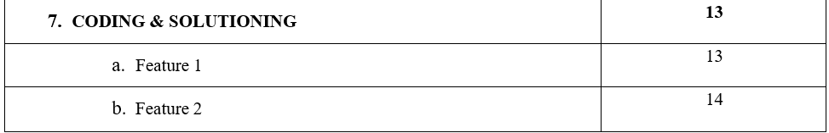

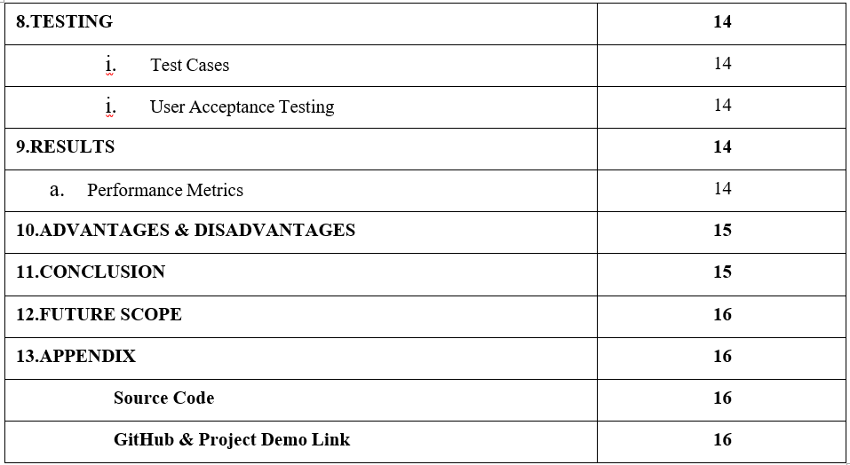

1. **INTRODUCTION:**
   1. **PROJECT**

This project helps for the patient to take medicine at correct

time.sometimes elderly people forget to take their medicine at the correct time,they also forget which medicine he/she should take at the particular time and it is diﬃcult for doctors/caretakers to monitor the patients around the lock.to avoid these kind of

problems.medicine reminder system is developed.

**1.2.PURPOSE:**

The main purpose of this system is to remind the medicine name to the patient at the correct a time by sending voice command through iot device/mobile

phone.

**2. LITERATURE SURVEY:**

* 1. **EXISTING PROBLEM:**

Patients who are suffering to identify their daily medicines due to their carelessness which causes health issues in their body and damage internal organs .by forgetting their medicines they risk their life in danger.

# 2.2.REFERENCES:

Andreas Handojo, Tioe Julio Adrian Sutiono, Anita Nathania

Purbowo,Metin Berke Yelaldı, Veliyullah Öztürk, Anıl Gün, Berke Küçüksağır, Alim Kerem Erdoğmuş, Uğur Yayan, Rifat Edizkan,Sawsan M. Mahmoud, Hesham A. Alabbasi, Tawﬁq

E. Abdulabbas,Rainer Lutze, Klemens Waldhör

# 2.3.PROBLEM STATEMENT DEFENITION:

When elders forgot to take their medicine that causes health issues.we can overcome this problem by help of this medicine reminder system by sending medicine name to their moblie phone through voice command.

**3.IDEATION&PROPOSED SOLUTON:**

**3.1.**   **EMPATHY MAP CONVAS:**

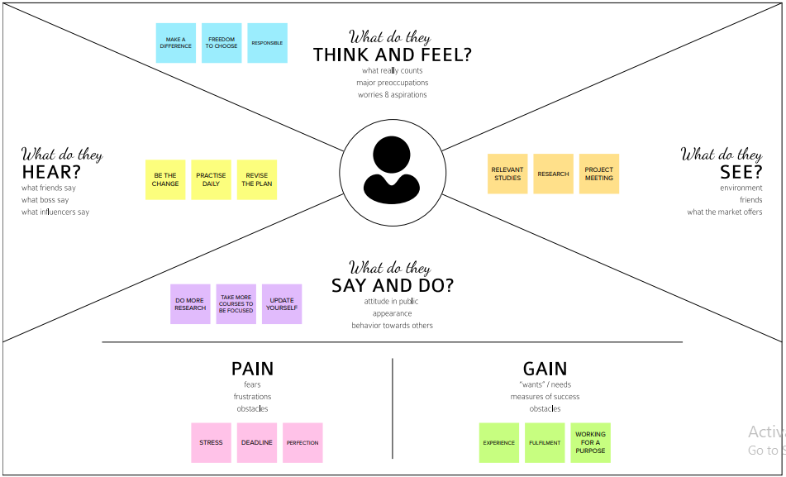

**3.2.IDEATION AND BRAINSORMING**

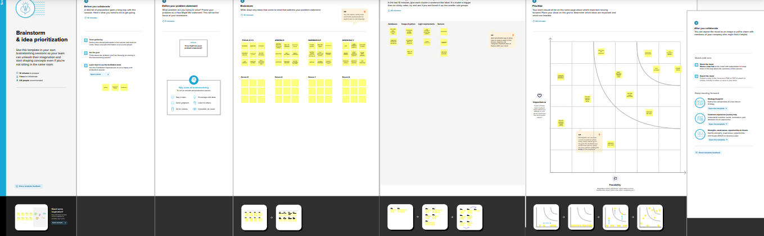

**3.3.PROPOSED SOLUTION:**

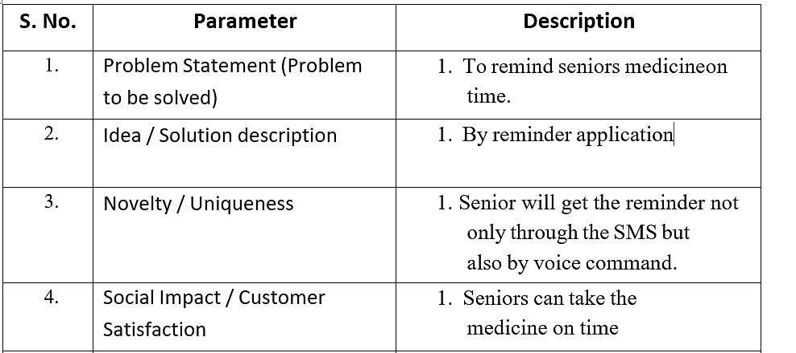

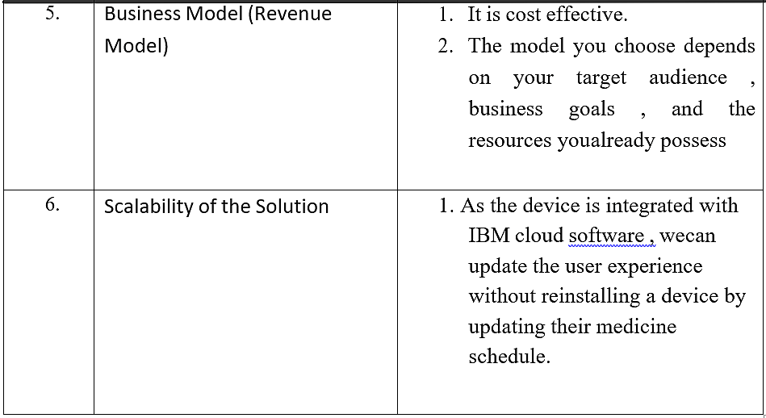

**3.4.PROBLEM SOLUTION FIT:**

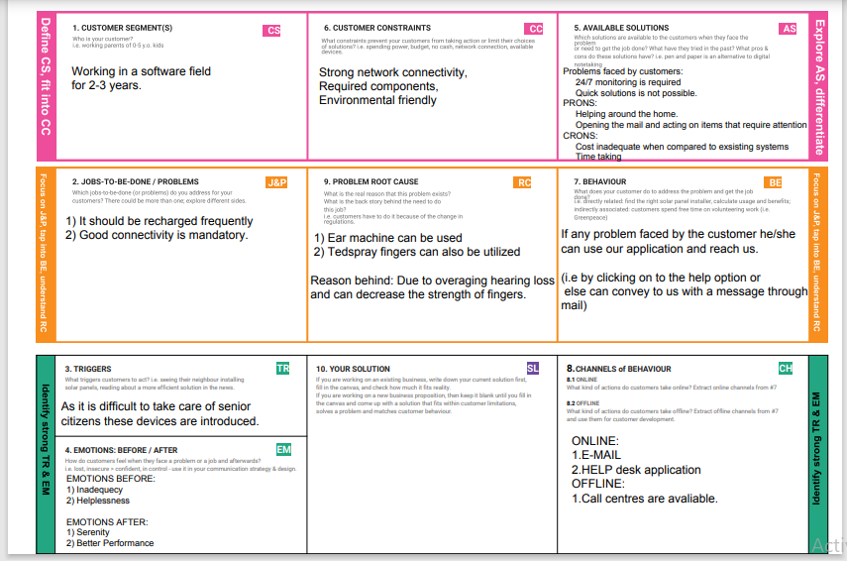

**4.REQUIREMENT ANALYSIS:**

**4.1.FUNCTIONAL REQUIREMENTS:**

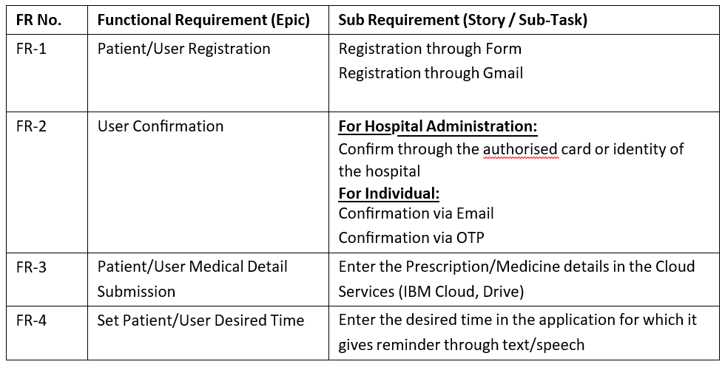

**4.2.NON-FUNCTIONAL REQUIREMENTS:**

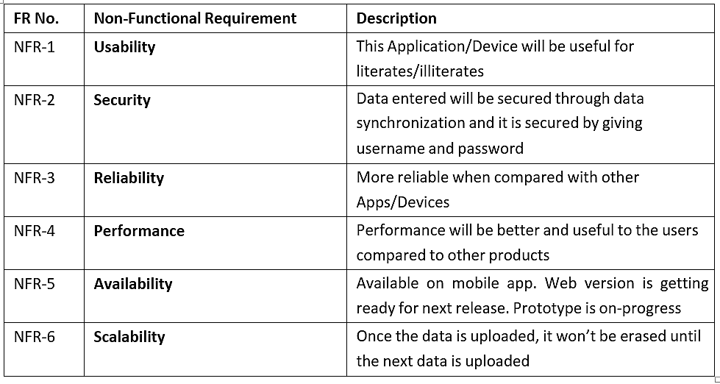

**5.PROJECT DESIGN:**

**5.1.DATA FLOW DIAGRAM:**

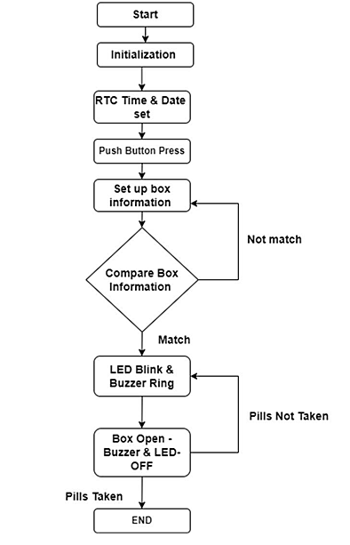

**5.2.SOLUTION AND TECHNICAL ARCHITECTURE:**

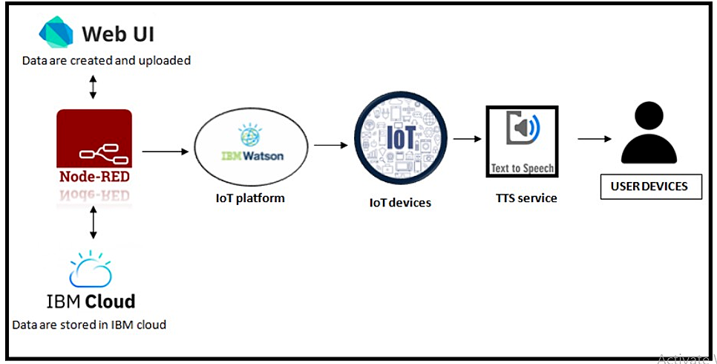

**6.PROJECT PLANNING AND SCHEDULING:**

**6.1.SPRINT PLANNING AND ESTIMATION:**

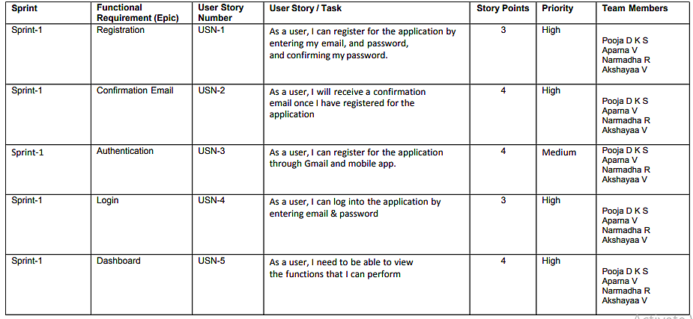

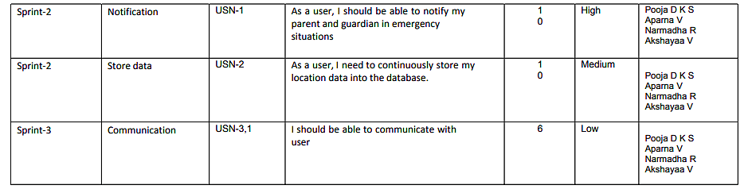

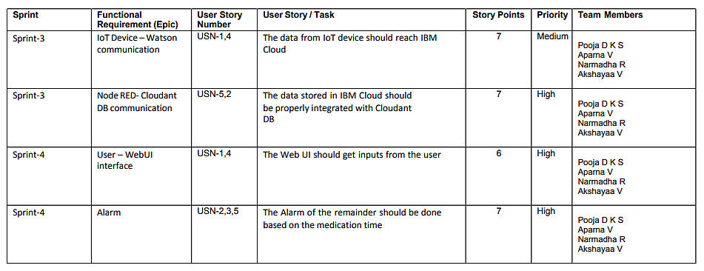

**6.2.SPRINT DELIVERY SCHEDULE:**

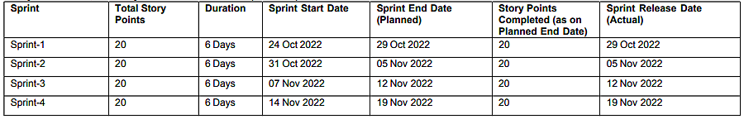

**7.REPORTS FROM JIRA:**

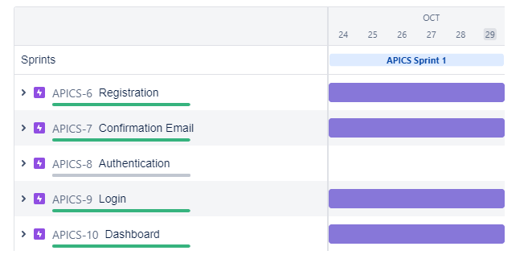

**7.CODING AND SOLUTIONING:**

**7.1.FEATURE 1:**

The mobile application developed has a feature of individual login by different users.

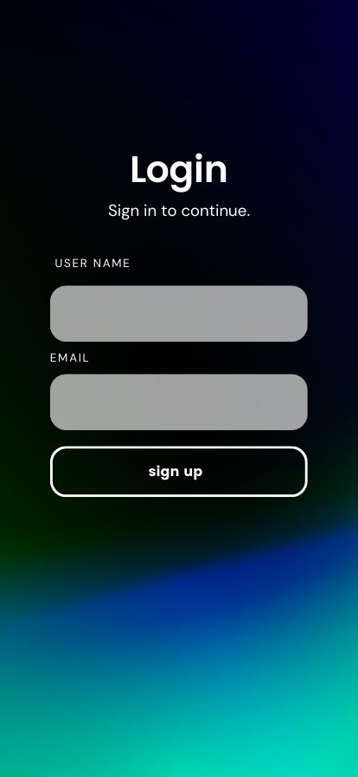

**7.2.FEATURE 2:**

The mobile application also has the feature of uploading medicine names in the cloud.

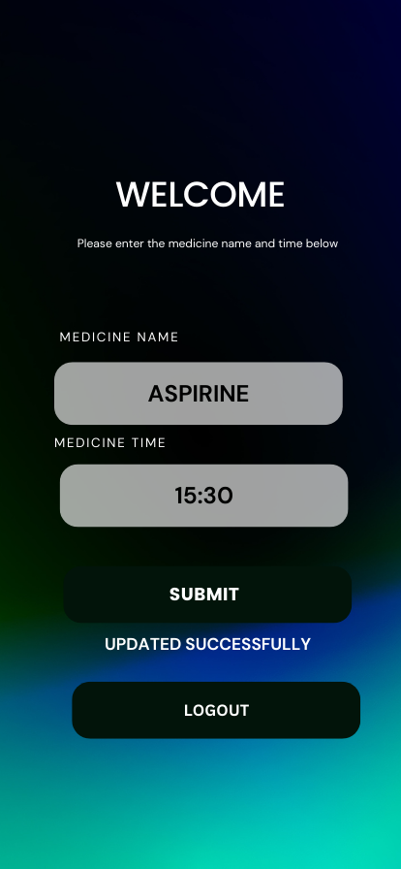

**7.3.FEATURE 3:**

                                           The project includes a cloud database system.

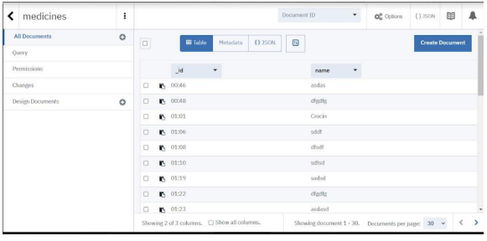

**8.TESTING:**

**8.1.TEST CASES:**

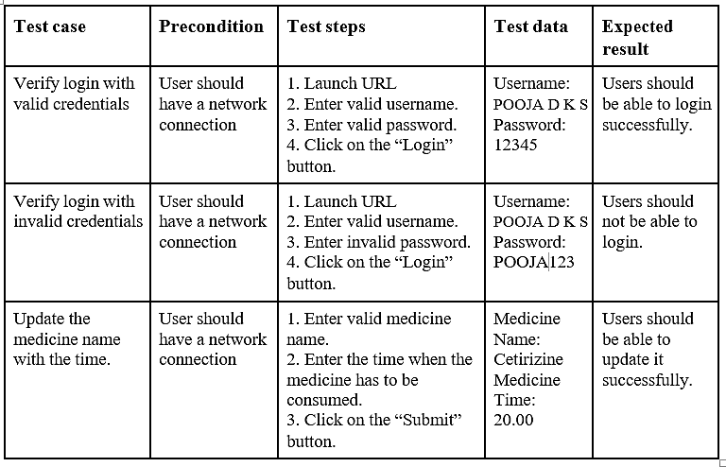

**8.2.USER ACCEPTANCE TESTING:**

**LOGIN PAGE TESTING:**



**INCORRECT LOGIN ATTEMPT:**

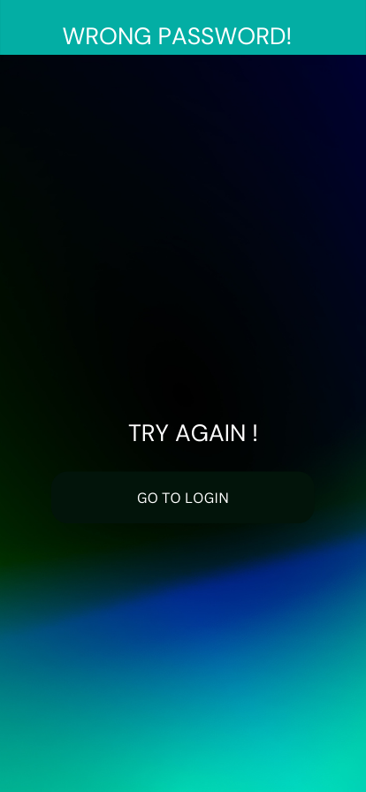

**9.RESULTS:**

**9.1.PERFORMANCE METRICS:**

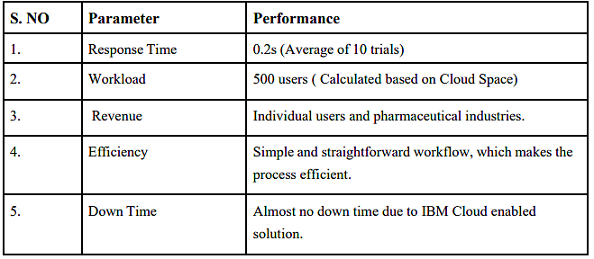

**10. ADVANTAGES AND DISADVANTAGES:**

**Advantages:**

➢ Help the elderly people to take their medicine at the correct time.

➢ Avoid personal assistants or caretakers needed for medically sick people.

➢ Cost efficient.

➢ Can store multiple data and many notifications can be generated.

➢ Since it includes voice assistance, even blind people can use our device. Disadvantages:

➢ Makes people lethargic and makes them dependent always on others.

➢ Requires a stable internet connection.

**11. CONCLUSION:**

The project offers the elderly or medically sick people a personal assistant which reminds them of the medicines to be consumed at the particular time. Skipping tablets may lead to serious problems if the person has a severe illness and this can be avoided. Since the cloud is integrated with the mobile application, numerous data can be fed into the database and notifications can be generated. The mobile application developed is highly customisable by the user and easy to use.

**12. FUTURE SCOPE:**

The project can be further developed by bringing into the feature of informing the medicine name during the notification. The voice assistance which is given can be customized by adding the user's voice or the caretaker’s voice. Further the mobile application can update medicines by taking voice commands as an input from the user.

**13. APENDIX:**

**SCHEMATIC DIAGRAM OF PROJECT AND COMPONENTS:**

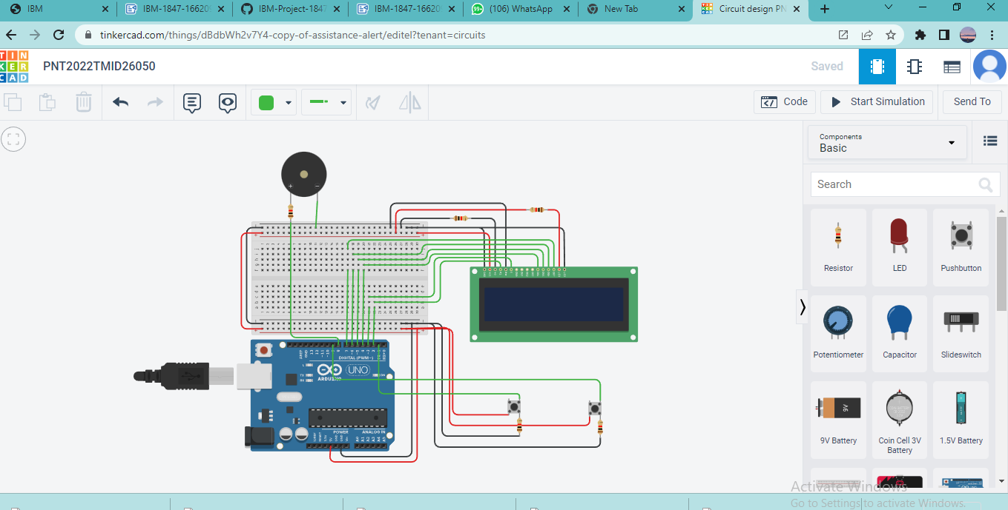

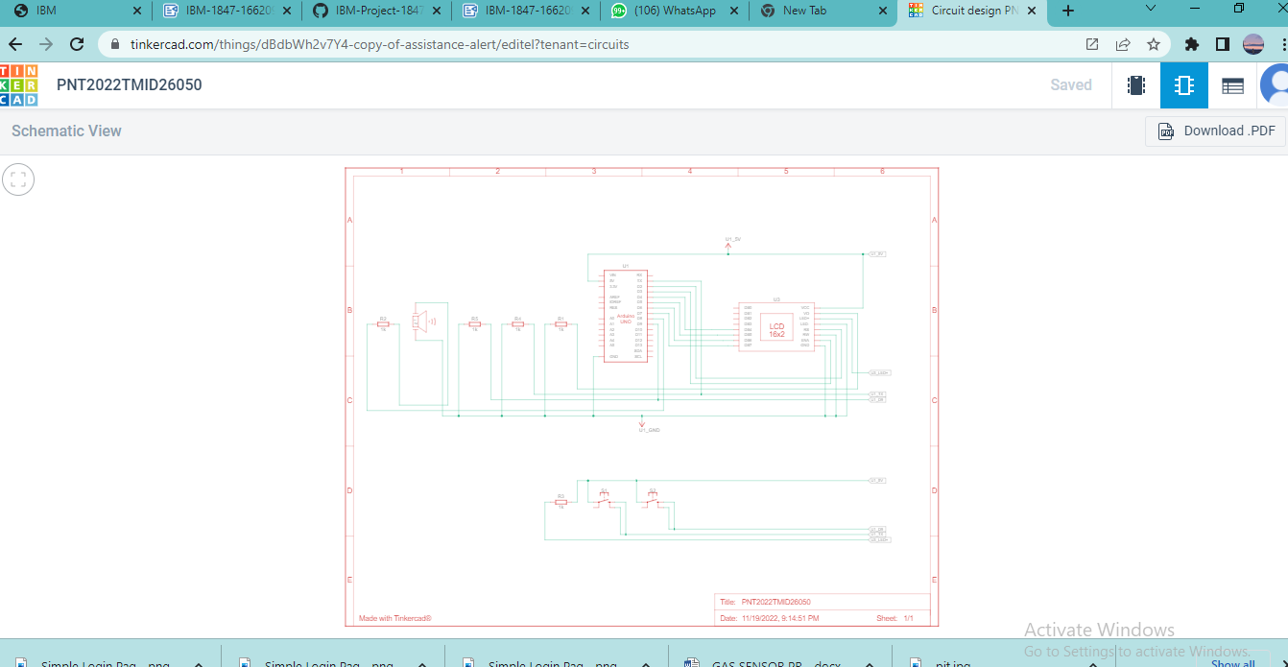

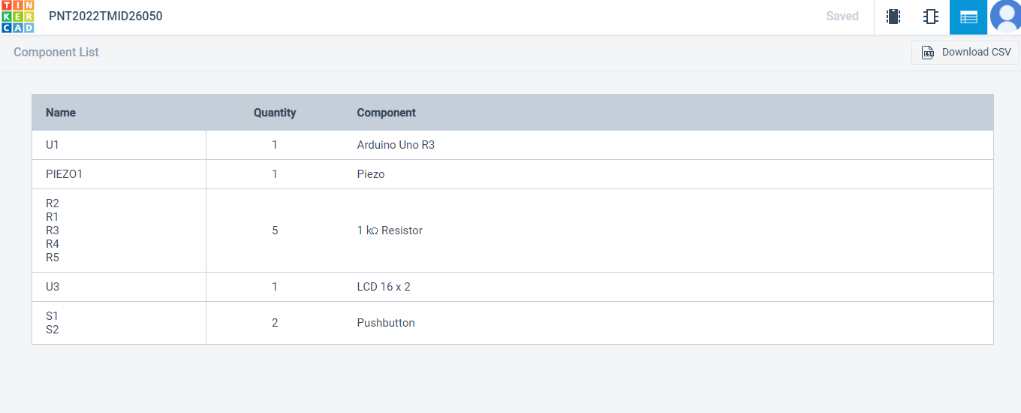

**SOURCE CODE:**

#include <LiquidCrystal.h>

const int rs = 2, en = 3, d4 = 4, d5 = 5, d6 = 6, d7 = 7;

LiquidCrystal lcd(rs, en, d4, d5, d6, d7);

const int buttonPin = 1;

const int buttonPin2 = 9;

const int buzzerPin = 8;

unsigned int state = LOW;

int previous = LOW;

unsigned int state2 = LOW;

int previous2 = LOW;

int safety_lim = 120;

long time = 0;

long time2 = 0;

long debounce = 100;

void setup()

{

  pinMode(buzzerPin, OUTPUT);

  pinMode(buttonPin, INPUT);

  pinMode(buttonPin2, INPUT);

  lcd.begin(16, 2);

  lcd.print("Assistance alert");

  lcd.setCursor(0, 1);

  lcd.print("system");

  delay(2000);

  lcd.clear();

  lcd.print(".");

  delay(700);

  lcd.print(".");

  delay(700);

  lcd.print(".");

  delay(1200);

  lcd.clear();

}

void loop()

{

  int reading = digitalRead(buttonPin);

  if (reading == HIGH && previous == LOW && millis() - time > debounce) {

    state = HIGH;

    state2 = LOW;

  time = millis();

  }

  previous = reading;

  if (state == HIGH) {

    lcd.clear();

lcd.print("Assistance");

    lcd.setCursor(0, 1);

    lcd.print("needed !");

    tone(buzzerPin, 700, 500);

delay(500);

noTone(buzzerPin);

delay(500);

  }

  int reading2 = digitalRead(buttonPin2);

  if (reading2 == HIGH && previous2 == LOW && millis() - time2 > debounce) {

    state = LOW;

    state2 = HIGH;

    time2 = millis();

  }

  previous2 = reading2;

  if (state2 == HIGH) {

    lcd.clear();

lcd.print("Alert stopped");

noTone(buzzerPin);

    delay(500);

  }

}

**GITHUB AND PROJECT LINKS:**

**GITHUB LINK:**

**https://github.com/IBM-EPBL/IBM-Project-1847-1658417780**

**DEMO LINK:**

**https://drive.google.com/file/d/1cGzh4Q_EWITFQiwzdhhu34XIxMPuKU8U/view?usp=sharing**